ASSESSMENT COVER SHEET

STUDENT (REGISTRATION) NUMBER: 40735842

MODULE NUMBER: ENI08108 2024-5 TR1 001.

MODULE TITLE: Operating Systems (ENUIC)

ASSESSMENT TITLE: ENI08108 Practical QP OS (Final Paper)

NAME OF MODULE LEADER: Athira Chitrapal.

DATE OF SUBMISSION: 09/12/2024

I declare, except where explicit acknowledgement is made of contributions from other sources*, that this assessment is the result of my own work and has not been submitted for any module or degree programme at Edinburgh Napier University or any other institution. This is in accordance with Edinburgh Napier University’s Academic Integrity Regulations.

*IMPORTANT: Contributions from other sources' may include incorrectly cited quotations or Artificial Intelligence (AI) tools, such as ChatGPT or Bard (details of which can be found in the Guidelines for Students on AI & Writing Assistant Tools). Please declare here whether you have used such tools in this assessment submission, and to what extent:

(Select one of the two options below):

☒ No, I have not used AI for this submission.

☐ Yes, I have used AI for this submission.

If you have used AI tools in completing this submission please briefly describe in approximately 100 words how you have used these tools:

Task 1. Scripting in a UNIX CLI.
I started this scripting in a UNIX assessment by searching vsoc2.napier.ac.uk, then I logged in there by my Napier student ID and pass, opened the vi-editor, made my directory by mkdir sifu, and started my practical.
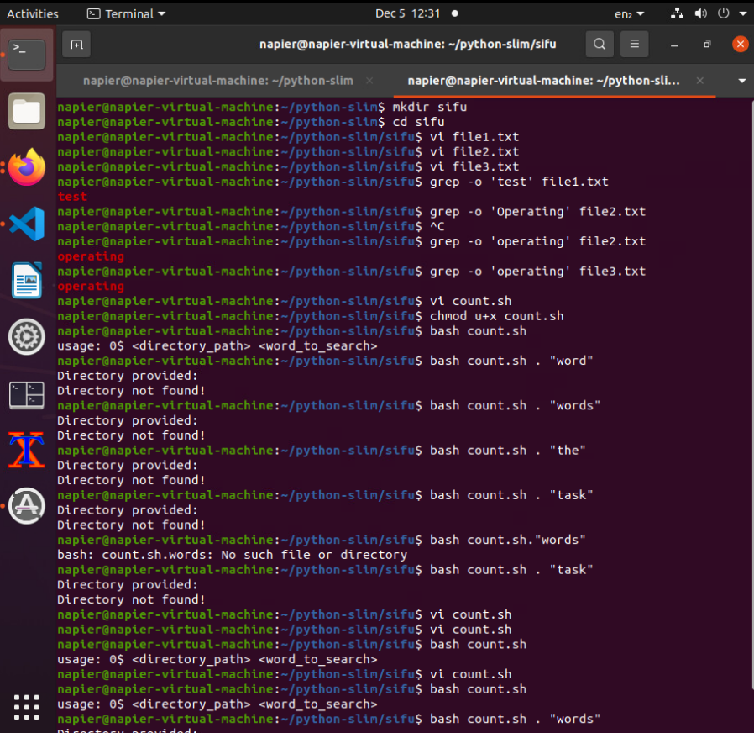

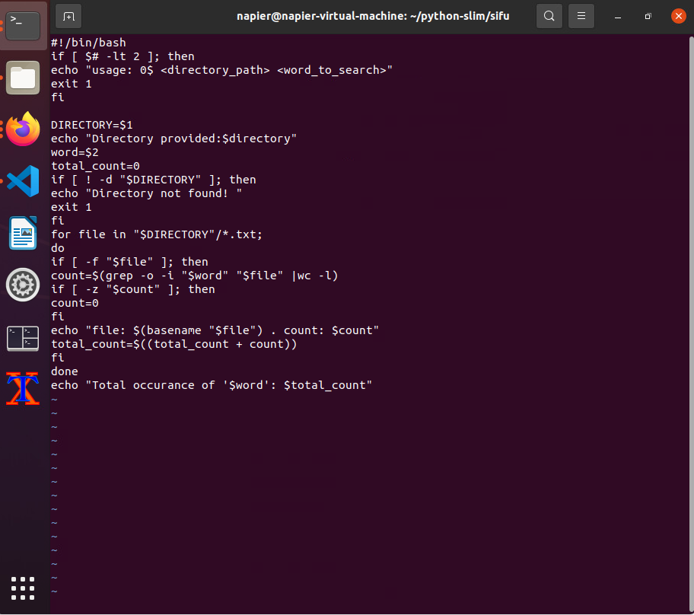
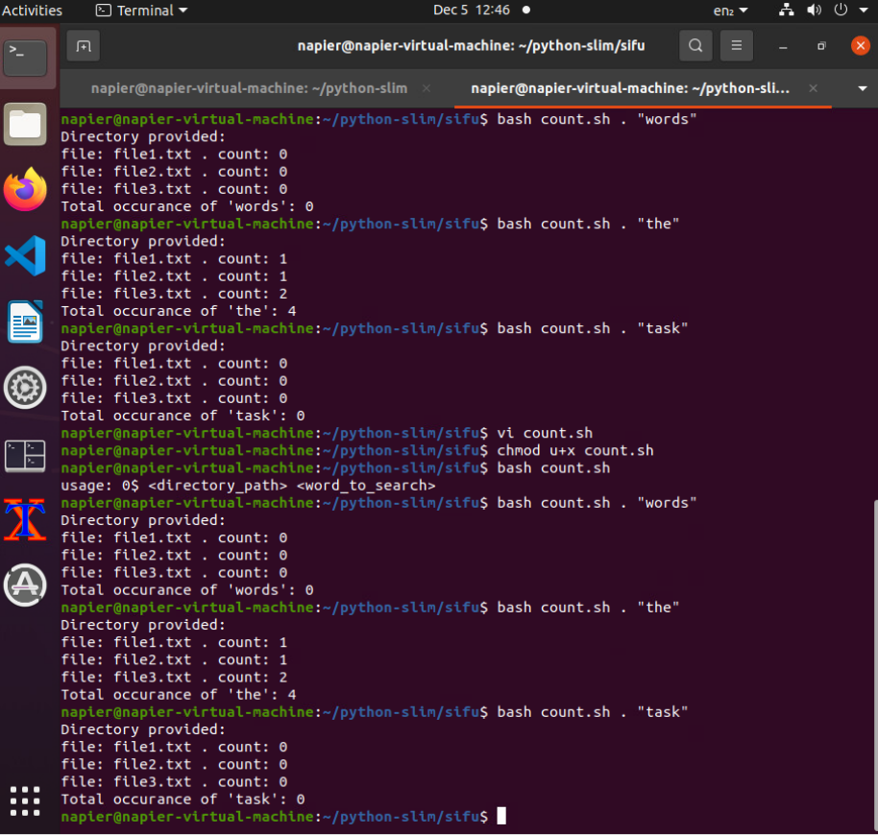
Descriptions of Task 1:
There are three screenshots of my bash script, which I started in Linux by using the command mkdir sifu and saving it by cd sifu. Then, following the questions of task 1, I created three different files by vi file name.txt, in which I followed the question instruction and file1.txt for the first one, file2.txt for the second one, and file3.txt for the last one. Then, the question’s instruction following is a screenshot of count.sh, which is a bash shell script. The commands used are grep to search for words and wc to count, all very basic shell scripting.
Screenshot of the file count.sh created/listed in the needed directory in the UNIX shell along with the text files file1.txt, file2.txt, and file3.txt.
"This screenshot shows the UNIX shell's directory listing and the count.sh script and the text files, which are file1.txt ‘test,’ file2.txt ‘operating,’ and file3.txt ‘operating,’ are rightly placed in the specified directory. This is very important for the running of the script effectively because these files will act like input to the script".
Screenshot of the output received after the successful completion of occurrences of words in UNIX shell.
The following is the screenshot of the results from running the count.sh script; it shows the counts for each of the given words through the three text files. This output is to test whether the script runs effectively and provides information that is necessary for analysis.

Task2. Implementing a solution to a standard scheduling problem encountered when programming with multiple process.
Description to Include:
"For the CPU scheduling problem, I have used the CPU-OS (02) simulator. This simulator simulates a number of CPU scheduling algorithms, including FCFS, SJF, and RR. The main features include the ability to visualize process states, manage process queues, and analyze the efficiency of scheduling with regard to arrival times and burst times. These features were very helpful in assessing the performance of different scheduling strategies."
a.
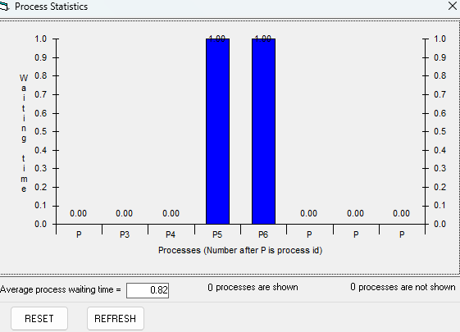

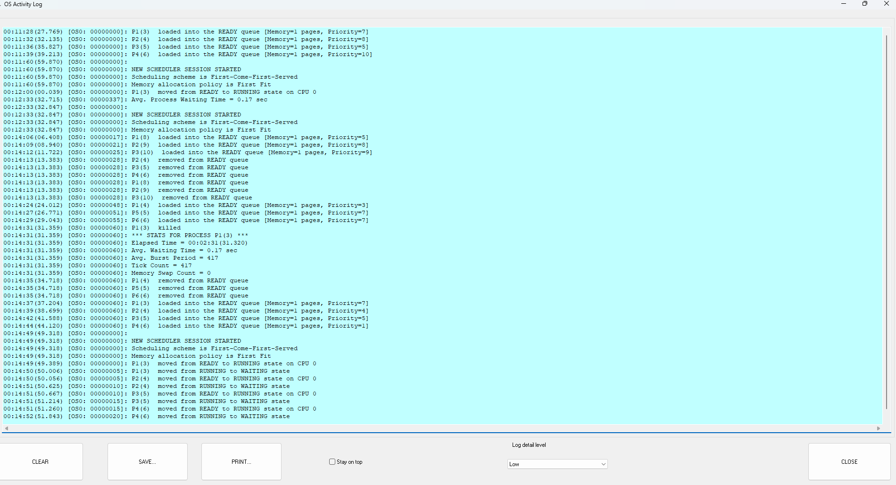
Screenshots showing the selection of each algorithm with the Processes according to their arrival time and Burst Time. The above screenshots show the selection process for each of the scheduling algorithms. In each case, the algorithms were selected with regard to arrival and burst times specific to the processes in question so that their respective performances could be contrasted.
b.
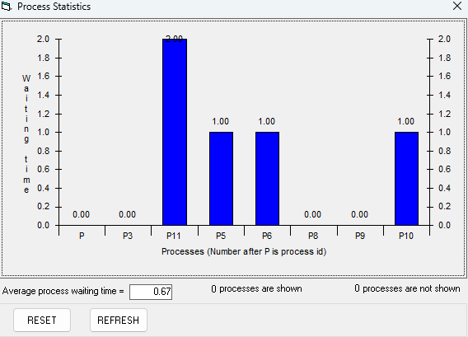
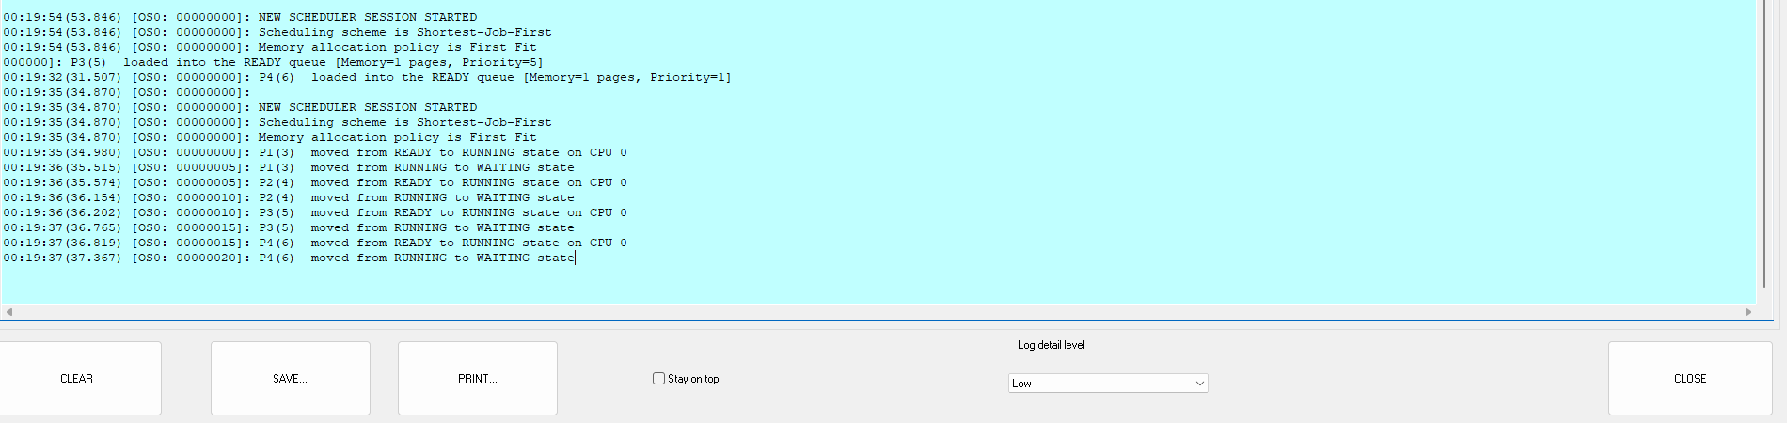
Screenshots showing the creation of processes to begin scheduling considering all other parameters necessary. "These screenshots show the way to create processes in this simulator. Each process will be set with parameters including arrival time, burst time, and priority, which should be considered for correct scheduling."

c.
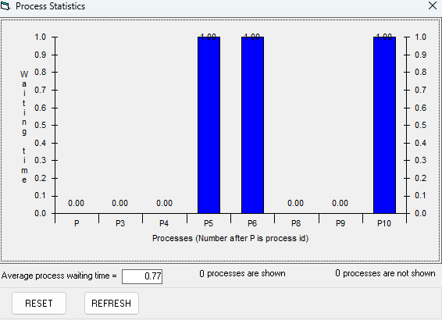
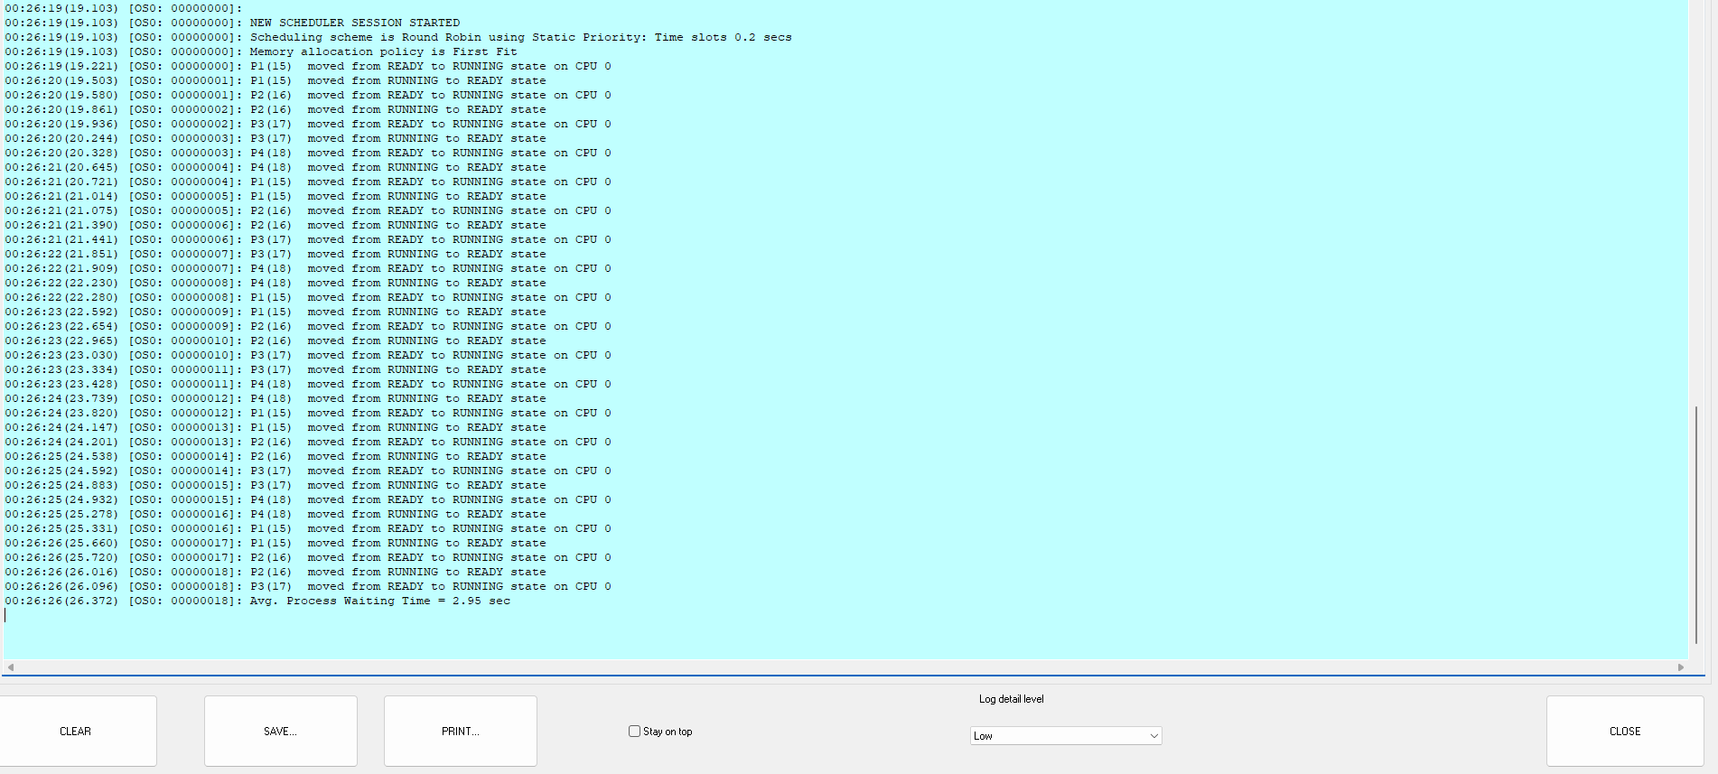
The following are screenshots showing the View log and View process States to find the efficient algorithm after CPU scheduling. The last set of screenshots show the log and process states after executing the scheduling algorithms. This information is very important in finding out the efficiency of every algorithm, as it gives insights into waiting times, turnaround times, and overall CPU utilization.

Task 3. Programming in bash interacting with the docker containers.
Description to Include:
The virtual machine was implemented using Docker for containerization and bash scripting for automation. Involving a Dockerfile defining the environment and dependencies that the application needs, bash scripts are used to automate the setup and configuration of the container so as to ensure a reproducible and consistent environment.
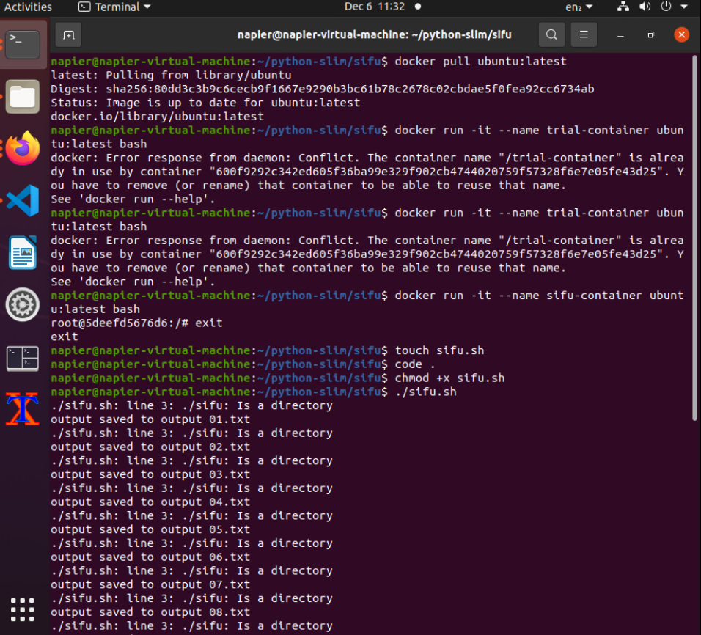

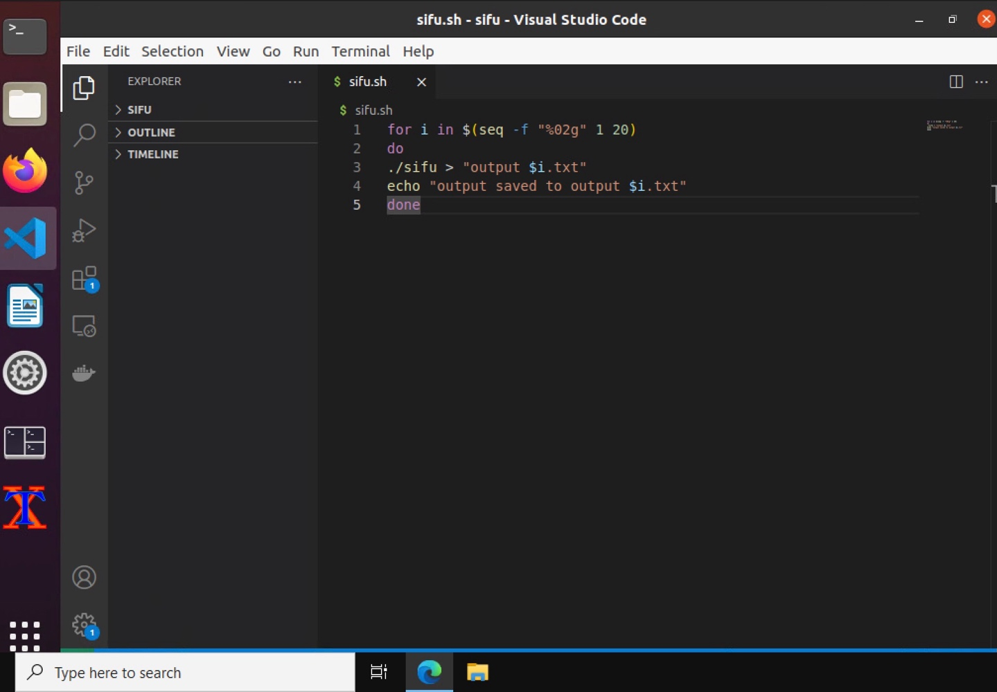

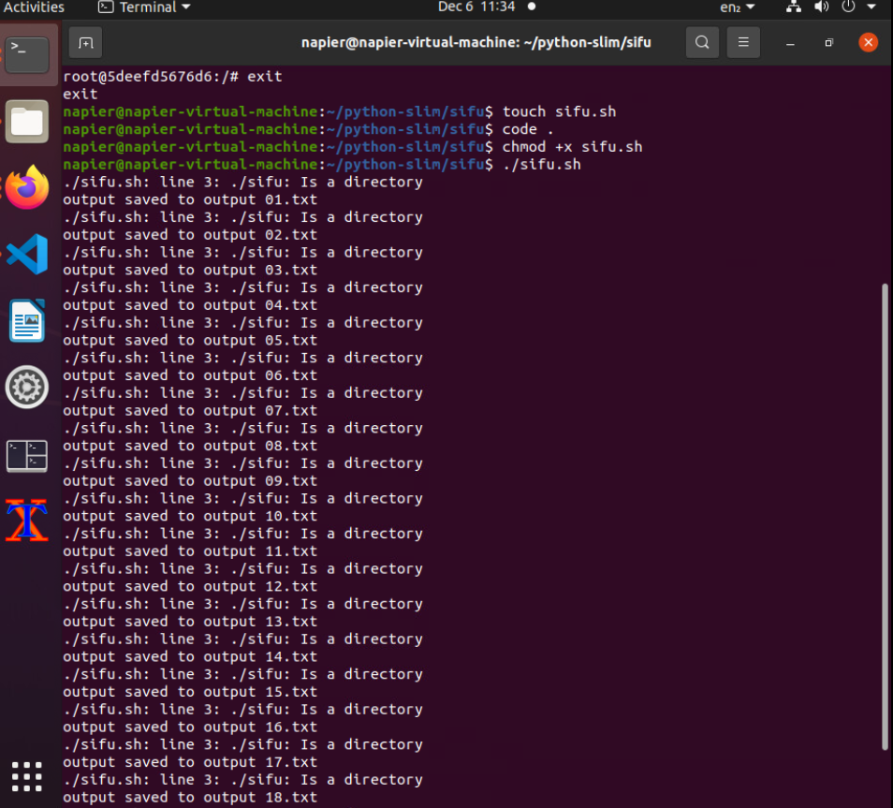
Screenshot of the necessary image pulled. The screenshot shows the successful pulling of the Docker image that is needed for the virtual machine. The image will act as the base environment for running the application. VS Code screenshot with the setup of the necessary environment for linking with Docker: This is a screenshot of Visual Studio Code, showing the setup of all necessary environments to link with Docker. This helps developers to easily work on and debug the application in a containerized environment.
Screenshot of the container created and running in UNIX shell.
Above is a screenshot of the running Docker container in the UNIX shell. This proves that the container has been created without errors and is up and running to execute the application.

